For Immediate Release
December 24, 2017

BANGLA BASS PIONEER, BROOKLYN SHANTI, RETURNS WITH BRAND NEW SINGLE “BLADE RUNNERS”
“The future’s uncertain, this is the beginning of a chain reaction.” – Brooklyn Shanti

SHANTI ANNOUNCES FOURTH ALBUM MISSED AMERICA (LA CRISIS)
ARRIVING EVERYWHERE JANUARY 17, 2018
[AVAILABLE FOR PRE-ORDER]

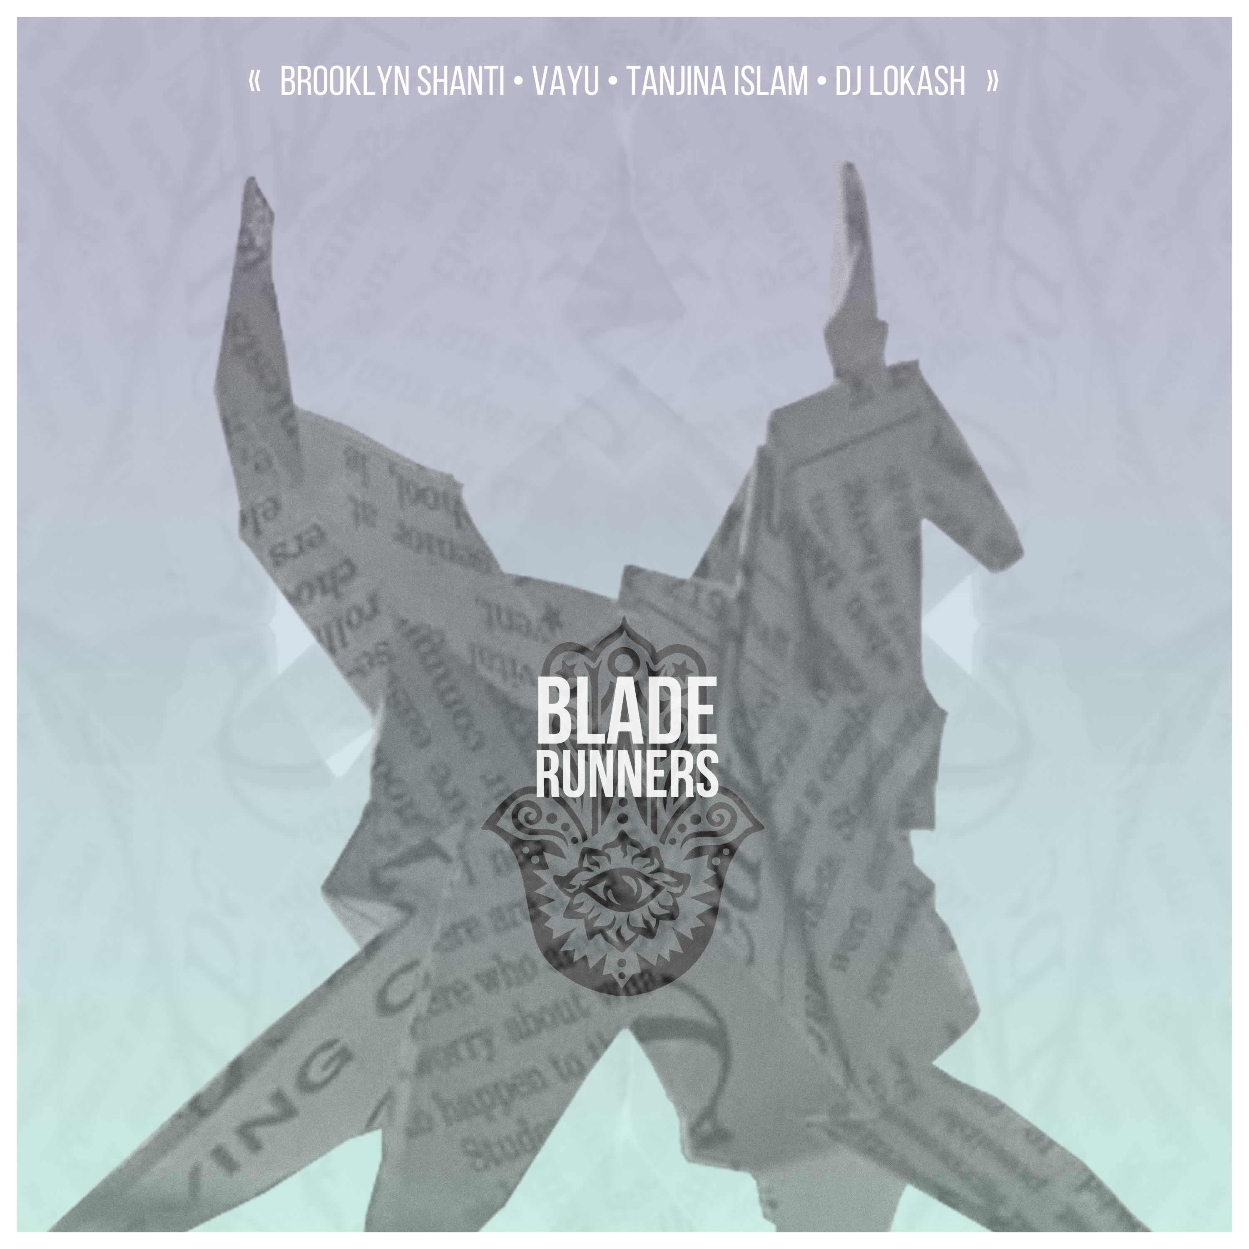 | LISTEN TO “BLADE RUNNERS”:  http://smarturl.it/bladerunners  MORE ON BROOKLYN SHANTI:  WEBSITE  FACEBOOK  TWITTER  INSTAGRAM  YOUTUBE

Critically acclaimed international rapper/singer/songwriter/producer/director/musician, Brooklyn Shanti, has unveiled his latest official single today. Self produced; the single features DJ Lokash from Cannibal Ox fame, newcomer Bengali vocalist Vayu and veteran Bengali songstress, Tanjina Islam. “Blade Runners” is now available for streaming and download at all DSPs. The multi-faceted Shanti has also announced his highly anticipated fourth studio album, Missed America (La Crisis), releasing worldwide January 17, 2018.

A video for “Blade Runners” is scheduled for release early January, set to drop on the artist’s YouTube channel, http://www.youtube.com/brooklynshanti, where he released a new video every Wednesday during 2017 while traveling the world with one backpack filled with recording and filming gear and an overhead compartment sized suitcase containing clothing. His forthcoming album and videos were created in this radical manner.

Please contact info@someplacecalledbrooklyn.com for more information, promo materials, and interview requests.

###

