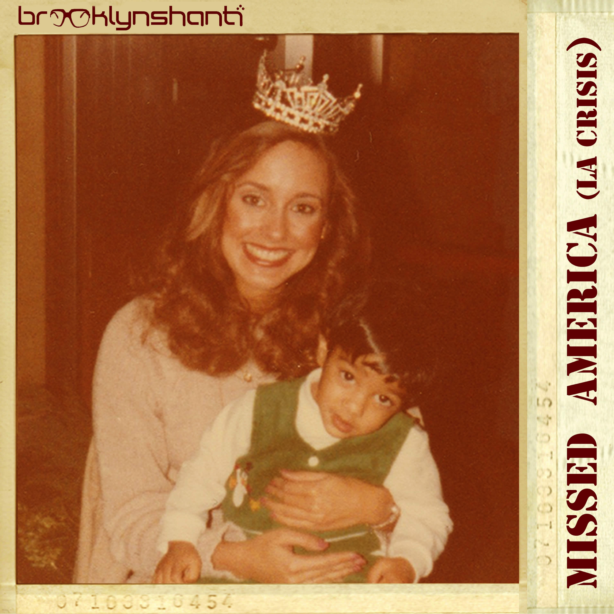  Release Date: January 17, 2018  Format: Digital Album  Label: Someplace Called Brooklyn  Catalog #: SCBK-027  Contact: info@someplacecalledbrooklyn.com | Artist: Brooklyn Shanti  Title: Missed America (La Crisis)  Tracklisting  01. Mumbai Fly ft. Dusty  02. Bengali Inna Di Dance ft. Vayu  03. Dictators ft. Deejay Chilly  04. Blockchain Insane ft. Dusty  05. Kolkata Jedi ft. Neon84  06. Blade Runners ft. Vayu, Tanjina Islam & DJ Lokash  07. Himalayan Houdini ft. Deejay Chilly & Dusty  08. Rachael Tyrell ft. Neon84  09. Sushma ft. Dub Sharma  10. Reality Czar ft. DJ Lokash  11. Electric Sheep (Mi Amore) ft. Pop as Hell  12. Magic Flying Rugs ft. E.L. Copeland  13. 2029  14. Missed America ft. Girasol  Soundcloud: http://bit.ly/2qZyIke
Brooklyn Shanti’s 4th studio album, “MISSED AMERICA (LA CRISIS)” touches on Trump’s nuclear button, AI eliminating humans & Bengali identity releases 1.17.18 via Someplace Called Brooklyn

Critically acclaimed international rapper/singer/songwriter/producer/director/musician, Nabin Laskar aka Brooklyn Shanti returns with his new album, Missed America (La Crisis). The fourteen-song, primarily self-produced collection, an eclectic blend of pop, dancehall, future & tropical bass, trap, dance music and 90s hip-hop, is available January 17, 2018.

2017 was a prolific year for Shanti. He spent the whole time moving incessantly across the planet with what was essentially a studio in a single backpack and a tiny suitcase for a couple changes of clothes. He created every step of the way - hopping from one media to the next, feeding off of the experiences he got himself into and people he surrounded himself with. On top of that, he managed to release a new song & video every Wednesday of the year. He describes the process as “the formulation of a unique perspective informed by embedding with artists in varied situations during the world’s current political and technological crises.” Missed America is Shanti making sense of it all.

Shanti’s experiences have given birth to songs such as Dictators and Reality Czar, which discuss the foreseeable dangers of nuclear winter spawned through social media, all the way to the foreshadowing of a dystopian future resulting from too much human reliance and trust on artificial intelligence (AI). Songs such as Electric Sheep, 2029 and Magic Flying Rugs, encourage the listener to, “think twice before putting your brain on autopilot and surrendering consciousness to Silicon Valley’s desire to turn life into a never-ending episode of Black Mirror,” says Shanti. Tropical bass, dembow, dancehall and sci-fi soundtrack Trap round out the track list, inspired by moments Shanti experienced while sustaining himself throughout the year as a global touring DJ and emcee. As a result, the album is as vibrant and eclectic as the artists it represents.

It was when Shanti sat down with Dum Dum Project group member, Sean “DJ Cavo” Dinsmore and Fab 5 Freddy on a trip to Mumbai in November that he realized “Missed America” would be the documentation of his observations and experiences. A week later, with the album fully written and a majority of it produced, he began traveling to fill in the missing collaborative gaps between Kolkata (Vayu), Gujarat (Dub Sharma), Seattle (Deejay Chilly), Los Angeles (Girasol), New York (DJ Lokash) and Washington D.C. (Dusty & Neon84).

About the album Shanti says, “America’s currently mirroring George Orwell’s 1984, and AI is falling in line with Philip K. Dick type stories that many sci-fi and cyberpunk authors have put in front of us for half a century, I’ve let those ideas run wild in this work.”

Another integral piece of Shanti’s puzzle as an artist from the beginning of this decade has been the conversation around Bengali identity and his own interpretation of it through his unique lens. Songs like Blade Runners and Bengali Inna Di Dance use passages from poetry and songs dating back to the Bengali Renaissance (Calcutta 1920s). Newcomer Vayu’s verse on Blade Runners is a reworking of a poem from Sukumar Ray’s Abol Tabol series. Says Shanti, “Afrika Bambaataa taught me that Cab Calloway could be considered the first emcee with Hi-De-Ho which was released in 1934 as children’s music – then there’s Abol Tabol which was also released as children’s poetry and music that dates back to 1923 in Bengal,” and adds, “these are connections we haven’t drawn between our cultures before, I’m Bengali from Brooklyn but make music for everyone, not just Bengali or Brooklyn people, it’s nice to share these discoveries through my work.”

Looking forward, “Missed America (La Crisis)” will also release in the form of a book of photography alongside the lyrics as poetry, a collaborative effort with longtime friend and multi-disciplinary artist/curator, Deejay Chilly of KEXP in Seattle, who makes multiple guest appearances on the album. The duo is currently working on a series of installation pieces that represent subject matter discussed on the album. The installation is scheduled to travel through the Pacific Northwest and West Coast late Spring 2018 as part of Shanti’s upcoming tour. In addition, Shanti produced and co-wrote several multi-genre full-length releases with artists ranging from hip-hop legend Akil the MC of Jurassic 5 and multi-genre pioneer Tittsworth, to dream pop vocalist Dani Mari, Chinese rap phenom Jason Chu, Bengali-language chanteuse Tanjina Islam and Bollywood star Evelyn Sharma, all releasing in 2018 via Someplace Called Brooklyn.

FIRST SINGLE “BLADE RUNNERS” DEBUTS AS “TRACK OF THE WEEK” ON BBC
Listen to the BBC interview here.

“Brooklyn Shanti, is on an ambitious quest to unite hip-hop, dance music, and a patchwork of styles from across the globe. So far he’s doing a bang-up job” – ENTERTAINMENT WEEKLY

“America’s biggest Indian rapper” – TIMES OF INDIA

“he isn't concerned with whether his music will make top 10 lists. He's more concerned with whether or not it will last forever.” – NPR

”Laskar has been innovatively transforming the South Asian approach to hip-hop.” – INDIA.COM

Please contact info@someplacecalledbrooklyn.com for more information, promo materials, and interview requests.
###

